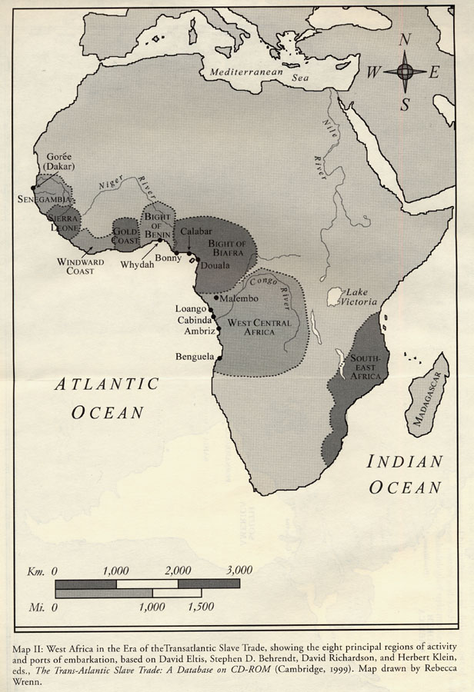

"New Perspectives on the Transatlantic Slave Trade," Special Issue, William and Mary Quarterly, vol. 58 (2001), between pp. 16 and 17.

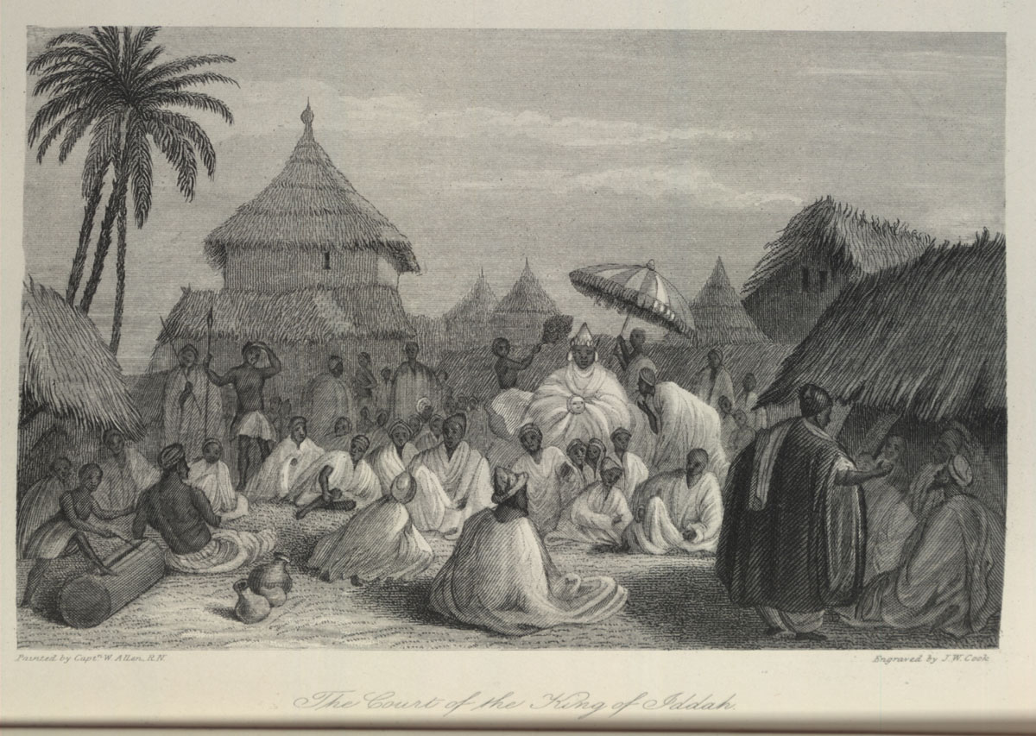

Source
William Allen, A Narrative of the Expedition sent by Her Majesty's Government to the River Niger, in 1841 (London, 1848), vol. 1, p. 293. (Copy in Special Collections, University of Virginia Library)
Comments
Caption, "The Court of the King of Iddah". Shows king in center, under umbrella; slit-gong drum in lower left. Iddah/Idah, a port on the Niger river, south of the Niger-Benue confluence in present-day south central Nigeria, was the "largest and the most important town in the Kingdom of Eggarah [Igara/Igala]". It was a major trading area for slaves taken to the Niger Delta and the Bight of Biafra. In this illustration, the king is "seen on a throne, formed of a bamboo frame, covered with mats and carpets . . . . He was almost smothered by his garments, and surrounded by attendants, who were fanning him vehemently . . . .The principal courtiers were seated close round the throne, with their backs towards it, excepting a large party [of Muslims]... these sat facing the king" (Allen, pp. 293-94, 318).

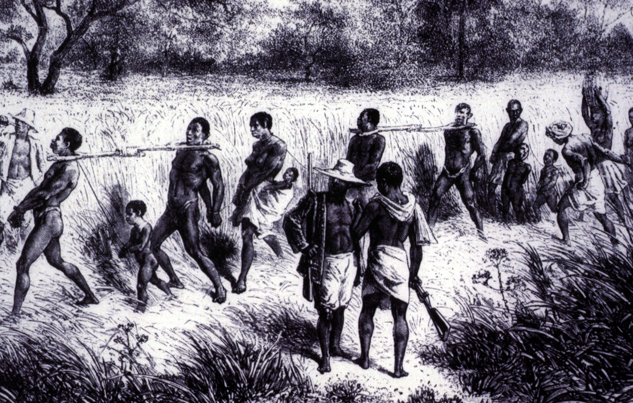

Source
Published in Anthony Tibbles (ed.), Transatlantic Slavery: Against Human Dignity (London: HMSO, 1994), p.106, fig. 23; the original source is not identified.
Comments
Men, women, children linked by wooden yokes and chains; African guards carry guns. This image is also published in James Walvin, An African's Life: The Life and Times of Olaudah Equiano, 1745-1797 (Cassell, 1998, p. 11) which cites the original source as Verney Lovett Cameron, Travels in Central Africa (1873); however, there is no book by that title under Cameron's authorship. The image is also in Walvin's Black Ivory (London, 1992), but no original source is identified. This image is one of several images derived from the original engraving in David and Charles Livingstone, Narrative of an Expedition to the Zambesi and its Tributaries (London, 1865); see image reference C019.

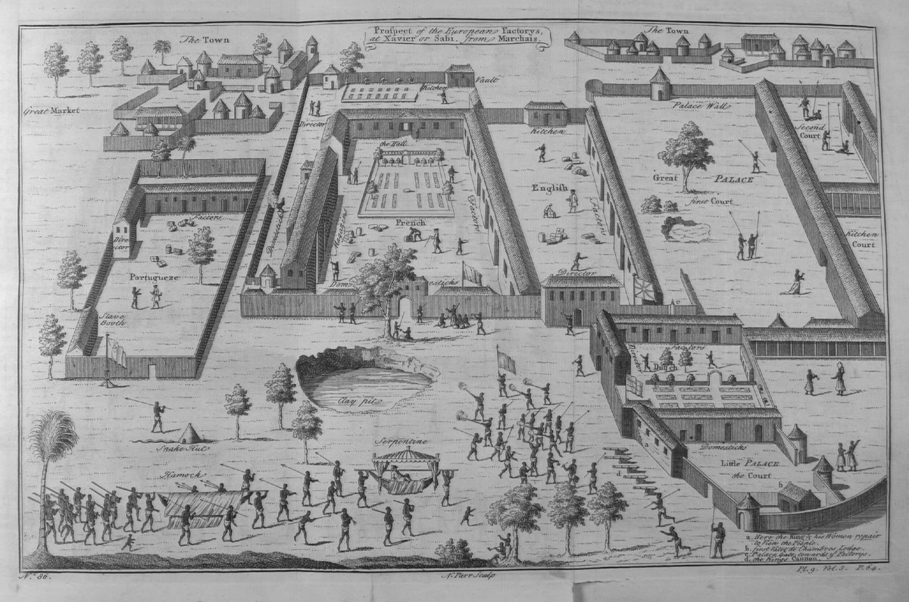
Source
Jean Baptiste Labat, Voyage du Chevalier des Marchais en Guinée . . .fait en 1725, 1726, & 1727 (Amsterdam, 1731), vol. 2 , between pp. 40-41, In Thomas Astley (ed.), A New General Collection of Voyages and Travels (London, 1745-47), vol. 3, plate 9, facing p. 64. (Copy in Special Collections, University of Virginia Library; also Library of Congress, Prints and Photographs Division, LC-USZ62-106828)

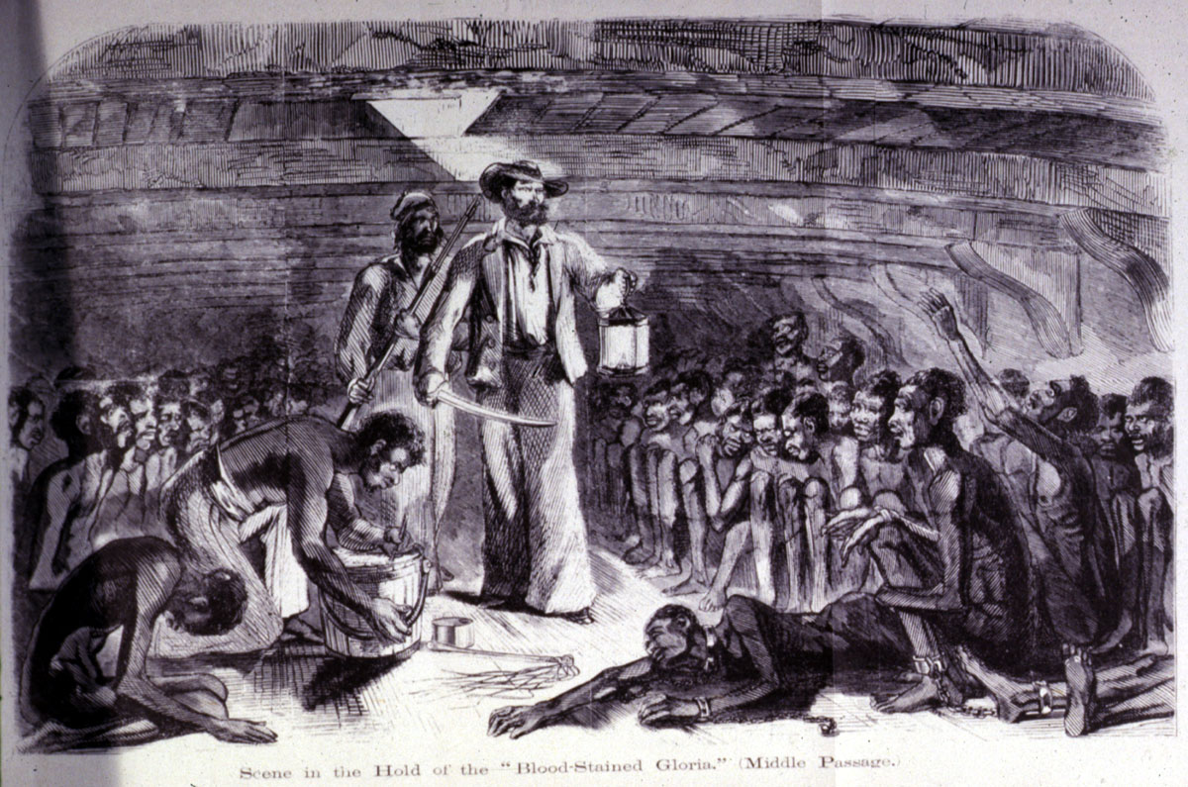

Source
Richard Drake, Revelations of a Slave Smuggler (New York, 1860), p.28. (Library of Congress, Prints and Photographs Division, LC-USZ62-30818)
Comments
Caption, "Scene in the Hold of the 'Blood-Stained Gloria' (Middle Passage)." The author sailed on the Gloria, a Brazilian slaver, for a half dozen trips over a two-year period; conditions aboard the ship are described on pp. 89-90. The illustration is also in the 1972 reprint of Drake's work (Metro Books, Northbrook, Ill.), foreward by Blyden Jackson.
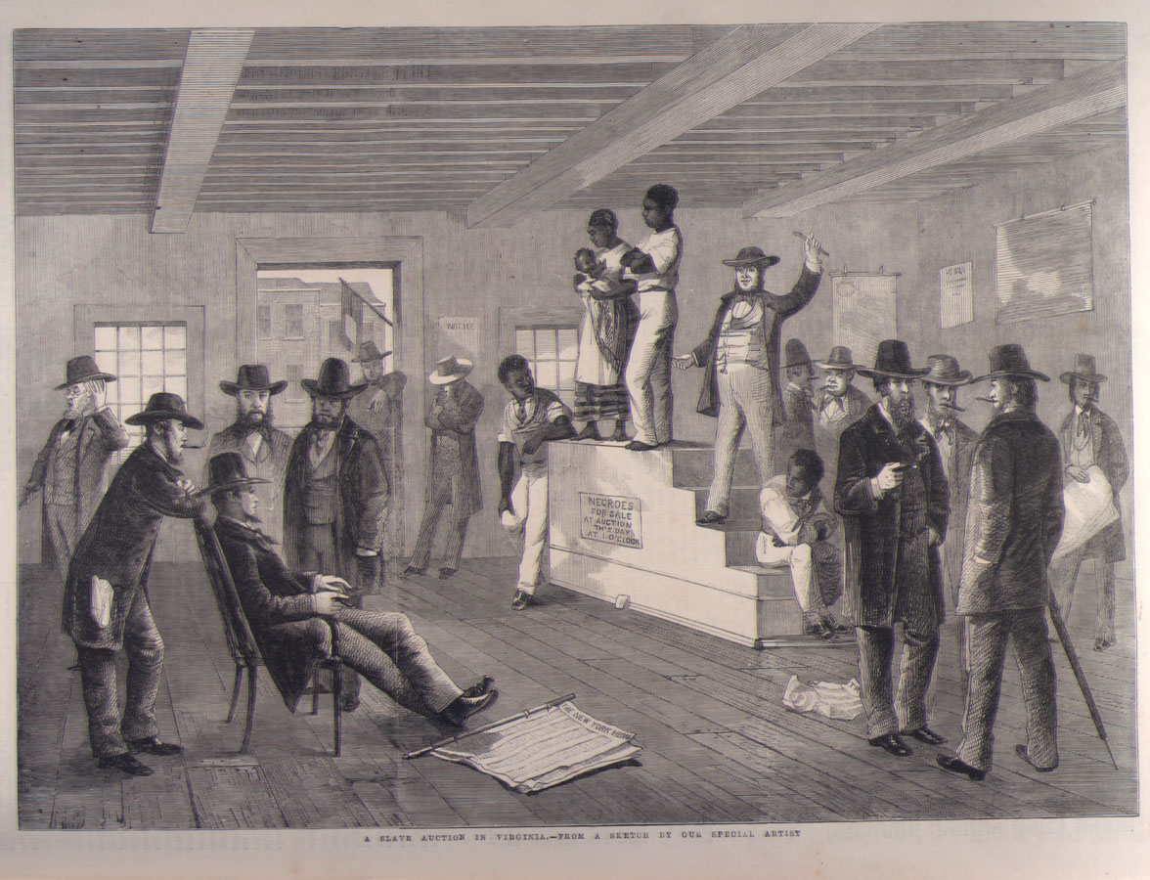
Source
The Illustrated London News (Feb. 16, 1861), vol. 38, p.139. (Copy in Special Collections Department, University of Virginia Library)
Comments
Shows a man and woman (with child in arms) on auction block, surrounded by white men. Article in the ILN accompanying this "sketch by our special correspondent" (G.H. Andrews) provides a lengthy eyewitness description of slave sales in Richmond, part of which is excerpted here: "The auction rooms for the sale of Negroes are situated in the main streets, and are generally the ground floors of the building; the entrance-door opens straight into the street, and the sale room is similar to any other auction room . . . . placards, advertisements, and notices as to the business carried on are dispensed with, the only indications of the trade being a small red flag hanging from the front door post, and a piece of paper upon which is written . . . this simple announcement--'Negroes for sale at auction' . . . ." From here there follows a detailed description of the scene shown in the illustration and the auction process (pp. 138 -140). A composite engraving, combining the auction block and people on the right shown in this image with the image of a slave being inspected for sale (see image NW0027) was published in the French publication L'illustration, Journal Universel (vol. 37 [1861], p. 148), misleadingly giving the impression that the scene is an original depiction of a slave sale in South Carolina; this illustration, in turn, appears on the Mary Evans Picture Library website with an unattributed source (picture no. 10044451).

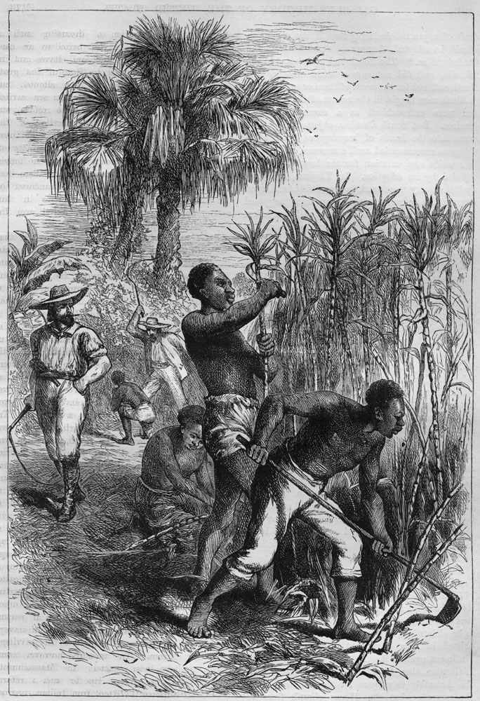
Source
Edmund Ollier, Cassell's History of the United States (London, 1874-77), Vol. 2, p. 493
Comments
Caption, "Slaves Working on a Plantation." This appears to be an illustration taken from another, unidentified, source, and is an artistic rendition. In the foreground, one man is cutting cane, another is weeding the fields with a hoe (the two activities do not occur concurrently in reality); a woman is kneeling tying the cane stalks into a bundle. A white overseer with a whip in hand is looking on while in the background another white is whipping an enslaved person. The location is not identified, but it is a tropical or semi-tropical scene, perhaps in the British or French West Indies. The illustration accompanies a discussion of slavery in the colonies in the 1780s, but does not seem to be directly related to what is discussed in the text.

