Elizabeth Cady Stanton

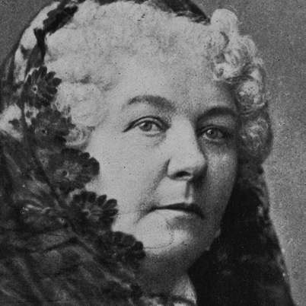
Born on November 12, 1815, in Johnstown, New York, Elizabeth Cady Stanton was an abolitionist and leading figure of the early woman's movement. An eloquent writer, her Declaration of Sentiments was a revolutionary call for women's rights across a variety of spectrums. Stanton was the president of the National Woman Suffrage Association for 20 years and worked closely with Susan B. Anthony.

Early Life

Women's rights activist, feminist, editor, and writer. Born on November 12, 1815, in Johnstown, New York. The daughter of a lawyer who made no secret of his preference for another son, she early showed her desire to excel in intellectual and other "male" spheres. She graduated from the Emma Willard's Troy Female Seminary in 1832 and then was drawn to the abolitionist, temperance, and women's rights movements through visits to the home of her cousin, the reformer Gerrit Smith.

In 1840 Elizabeth Cady Stanton married a reformer Henry Stanton (omitting “obey” from the marriage oath), and they went at once to the World's Anti-Slavery Convention in London, where she joined other women in objecting to their exclusion from the assembly. On returning to the United States, Elizabeth and Henry had seven children while he studied and practiced law, and eventually they settled in Seneca Falls, New York.

Women's Rights Movement

With Lucretia Mott and several other women, Elizabeth Cady Stanton held the famous Seneca Falls Convention in July 1848. At this meeting, the attendees drew up its “Declaration of Sentiments” and took the lead in proposing that women be granted the right to vote. She continued to write and lecture on women's rights and other reforms of the day. After meeting Susan B Anthony in the early 1850s, she was one of the leaders in promoting women's rights in general (such as divorce) and the right to vote in particular.

During the Civil War Elizabeth Cady Stanton concentrated her efforts on abolishing slavery, but afterwards she became even more outspoken in promoting women suffrage. In 1868, she worked with Susan B. Anthony on the Revolution, a militant weekly paper. The two then formed the National Woman Suffrage Association (NWSA) in 1869. Stanton was the NWSA’s first president - a position she held until 1890. At that time the organization merged with another suffrage group to form the National American Woman Suffrage Association. Stanton served as the president of the new organization for two years.

Lucretia Mott

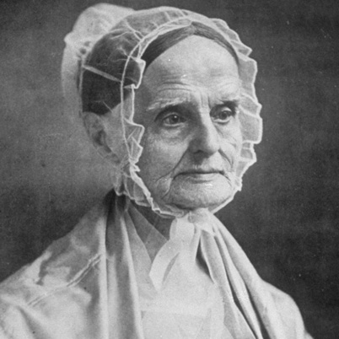
Born Lucretia Coffin on January 3, 1793, in Nantucket, Massachusetts, Lucretia Mott was a women's rights activist, abolitionist, and religious reformer. Mott was strongly opposed to slavery and a supporter of William Lloyd Garrison and his American Anti-Slavery Society. She was dedicated to women's rights, publishing her influential Discourse on Woman and founding Swarthmore College. Mott died in Pennsylvania in 1880.

Early Life

Women's rights activist, abolitionist and religious reformer Lucretia Mott was born Lucretia Coffin on January 3, 1793, in Nantucket, Massachusetts. A child of Quaker parents, Mott grew up to become a leading social reformer. At the age of 13, she attended a Quaker boarding school in New York State. She stayed on and worked there as a teaching assistant. While at the school, Mott met her future husband James Mott. The couple married in 1811 and lived in Philadelphia.

Civil Rights Activist

By 1821, Lucretia Mott became a Quaker minister, noted for her speaking abilities. She and her husband went over with the more progressive wing of their faith in 1827. Mott was strongly opposed to slavery, and advocated not buying the products of slave labor, which prompted her husband, always her supporter, to get out of the cotton trade around 1830. An early supporter of William Lloyd Garrison and his American Anti-Slavery Society, she often found herself threatened with physical violence due to her radical views.

Lucretia Mott and her husband attended the famous World's Anti-Slavery Convention in London in 1840, the one that refused to allow women to be full participants. This led to her joining Elizabeth Cady Stanton in calling the famous Seneca Falls Convention in New York in 1848 (at which, ironically, James Mott was asked to preside), and from that point on she was dedicated to women's rights and published her influential Discourse on Woman (1850).

While remaining within the Society of Friends, in practice and beliefs Mott actually identified increasingly with more liberal and progressive trends in American religious life, even helping to form the Free Religious Association in Boston in 1867.

Final Years

While keeping up her commitment to women's rights, Mott also maintained the full routine of a mother and housewife, and continued after the Civil War to work for advocating the rights of African Americans. She helped to found Swarthmore College in 1864, continued to attend women's rights conventions, and when the movement split into two factions in 1869, she tried to bring the two together.

Mott died on November 11, 1880, in Chelton Hills (now part of Philadelphia), Pennsyvlania.

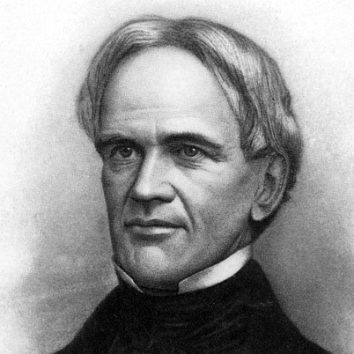
Horace Mann

Education reformer Horace Mann was born on May 4, 1796 in Franklin, Massachusetts. Mann served in the Massachusetts House of Representatives and Senate before his appointment as the Massachusetts secretary of education. Mann went on to the U.S. House of Representatives, promoting an agenda of public education and "normal schools" to train teachers.

Horace Mann was born into poverty in Franklin, Massachusetts, in 1796. Chiefly self-taught, Mann was 20 years old when he was admitted to the sophomore class at Brown University.

There he took an interest in politics, education and social reform, and upon graduation he gave a speech on the advancement of the human race through which education, philanthropy, and republicanism could combine to benefit mankind.

Professional Life

After Brown, Mann practiced law before winning a seat in the Massachusetts House of Representatives, where he served from 1827 to 1833. From 1835 to 1837, he served in the Massachusetts Senate, spending time as the majority leader and aiming his sights at infrastructure improvements via the construction of railroads and canals, among other projects.

The Educational Reform Movement Begins

While Mann served in the Senate, the Massachusetts education system, with a history going back to 1647, was suffering, and the quality of education was deteriorating. Soon a vigorous reform movement arose, and in 1837 the state created the nation’s first board of education, with Mann as its secretary.

With funds for the board’s activities at a minimum, the position required more moral leadership than anything else, and Horace Mann proved himself up to the role. He started a biweekly journal, Common School Journal, in 1838 for teachers and lectured on education to all who would listen.

Mann's Six Principles of Education

At this time he also developed his hugely influential, although at the time controversial, main principles regarding public education and its troubles: (1) Citizens cannot maintain both ignorance and freedom; (2) This education should be paid for, controlled, and maintained by the public; (3) This education should be provided in schools that embrace children from varying backgrounds; (4) This education must be nonsectarian; (5) This education must be taught using tenets of a free society; and (6) This education must be provided by well-trained, professional teachers.

Mann’s words angered groups across the social and political spectrum -- from clergymen to educators to politicians -- but his ideas prevailed and still do today. Mann served in the U.S. House of Representatives from 1848 to 1853 and then became the president of Antioch College. A commencement speech he gave two months before his death served as a clarion call, asking students to embrace his influential worldview: “I beseech you to treasure up in your hearts these my parting words: Be ashamed to die until you have won some victory for humanity.”
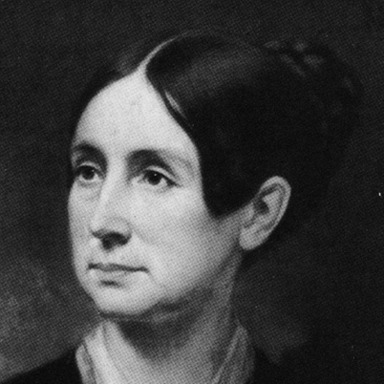
Dorothea Lynde Dix

Born in Hampden, Maine, in 1802, Dorothea Dix was a social reformer whose devotion to the welfare of the mentally ill led to widespread international reforms. After seeing horrific conditions in a Massachusetts prison, she spent the next 40 years lobbying U.S. and Canadian legislators to establish state hospitals for the mentally ill. Her efforts directly affected the building of 32 institutions in the United States.

Dorothea Lynde Dix was born on April 4, 1802, in Hampden, Maine. She was the eldest of three children, and her father, Joseph Dix, was a religious fanatic and distributor of religious tracts who made Dorothea stitch and paste the tracts together, a chore she hated.

At age 12, Dix left home to live with her grandmother in Boston, and then an aunt in Worcester, Massachusetts. She began teaching school at age 14. In 1819, she returned to Boston and founded the Dix Mansion, a school for girls, along with a charity school that poor girls could attend for free. She began writing textbooks, with her most famous, Conversations on Common Things, published in 1824.

Champion of the Mentally Ill

The course of Dix’s life changed in 1841, when she began teaching Sunday school at the East Cambridge Jail, a women’s prison. She discovered the appalling treatment of the prisoners, particularly those with mental illnesses, whose living quarters had no heat. She immediately went to court and secured an order to provide heat for the prisoners, along with other improvements.

She began traveling around the state to research the conditions in prisons and poorhouses, and ultimately crafted a document that was presented to the Massachusetts legislature, which increased the budget to expand the State Mental Hospital at Worcester. But Dix wasn’t content with reforms in Massachusetts. She toured the country documenting the conditions and treatment of patients, campaigning to establish humane asylums for the mentally ill and founding or adding additions to hospitals in Rhode Island, New York, New Jersey, Pennsylvania, Indiana, Illinois, Kentucky, Tennessee, Missouri, Maryland, Louisiana, Alabama, South Carolina and North Carolina.

Dix also lobbied at the federal level, and in 1848 she asked Congress to grant more than 12 million acres of land as a public endowment to be used for the benefit of the mentally ill as well as the blind and deaf. Both houses of Congress approved the bill, but in 1854 it was vetoed by President Franklin Pierce.

Discouraged by the setback, Dix went to Europe. She discovered enormous disparity between public and private hospitals, and great differences among countries. She recommended reforms in many countries, and, most significant, met with Pope Pius IX, who personally ordered construction of a new hospital for the mentally ill after hearing her report.

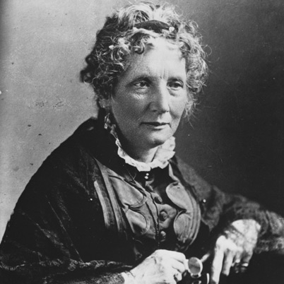
Harriet Beecher Stowe

Harriet Beecher Stowe was born on June 14, 1811, in Litchfield, Connecticut. Her father, Lyman Beecher, was a leading Congregationalist minister and the patriarch of a family committed to social justice. Stowe achieved national fame for her anti-slavery novel, Uncle Tom’s Cabin, which fanned the flames of sectionalism before the Civil War. Stowe died in Hartford, Connecticut, on July 6, 1896.

Early Life

Harriet Elizabeth Beecher was born on June 14, 1811, in Litchfield, Connecticut. She was one of 13 children born to religious leader Lyman Beecher and his wife, Roxanna Foote Beecher, who died when Harriet was a child. Harriet’s seven brothers grew up to be ministers, including the famous leader Henry Ward Beecher. Her sister Catharine Beecher was an author and a teacher who helped to shape Harriet’s social views. Another sister, Isabella, became a leader of the cause of women’s rights.

Harriet enrolled in a school run by Catharine, following the traditional course of classical learning usually reserved for young men. At the age of 21, she moved to Cincinnati, Ohio, where her father had become the head of the Lane Theological Seminary.

Lyman Beecher took a strong abolitionist stance following the pro-slavery Cincinnati Riots of 1836. His attitude reinforced the abolitionist beliefs of his children, including Stowe. Stowe found like-minded friends in a local literary association called the Semi-Colon Club. Here, she formed a friendship with fellow member and seminary teacher Calvin Ellis Stowe. They were married on January 6, 1836, and eventually moved to a cottage near in Brunswick, Maine, close to Bowdoin College.

Career

Along with their interest in literature, Harriet and Calvin Stowe shared a strong belief in abolition. In 1850, Congress passed the Fugitive Slave Law, prompting distress and distress in abolitionist and free black communities of the North. Stowe decided to express her feelings through a literary representation of slavery, basing her work on the life of Josiah Henson and on her own observations. In 1851, the first installment of Stowe’s novel, Uncle Tom’s Cabin, appeared in the National Era. Uncle Tom's Cabin was published as a book the following year and quickly became a best seller.

Stowe’s emotional portrayal of the impact of slavery, particularly on families and children, captured the nation's attention. Embraced in the North, the book and its author aroused hostility in the South. Enthusiasts staged theatrical performances based on the story, with the characters of Tom, Eva and Topsy achieving iconic status.

After the Civil War began, Stowe traveled to Washington, D.C., where she met with Abraham Lincoln. A possibly apocryphal but popular story credits Lincoln with the greeting, “So you are the little woman who wrote the book that started this great war.” While little is known about the meeting, the persistence of this story captures the perceived significance of Uncle Tom’s Cabin in the split between North and South.
Frederick Douglass

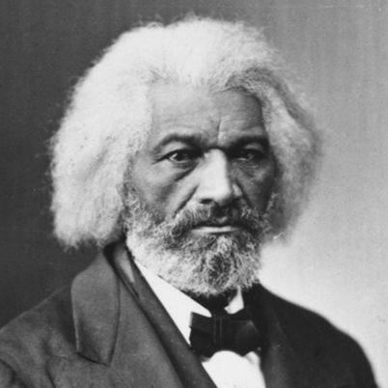
Abolitionist leader Frederick Douglass was born into slavery in Talbot County, Maryland. He became one of the most famous intellectuals of his time, advising presidents and lecturing to thousands on a range of causes, including women’s rights and Irish home rule. Among Douglass’ writings are several autobiographies eloquently describing his experiences in slavery and his life after the Civil War.

Frederick Augustus Washington Bailey was born into slavery in Talbot County, Maryland, around 1818. The exact year and date of Douglass' birth are unknown, though later in life he chose to celebrate it on February 14. Douglass lived with his maternal grandmother, Betty Bailey. At a young age, Douglass was selected in live in the home of the plantation owners, one of whom may have been his father. His mother, an intermittent presence in his life, died when he was around 10.

Frederick Douglass was given to Lucretia Auld, the wife of Thomas Auld, following the death of his master. Lucretia sent Frederick to serve her brother-in-law, Hugh Auld, at his Baltimore home. It was at the Auld home that Frederick Douglass first acquired the skills that would vault him to national celebrity. Defying a ban on teaching slaves to read and write, Hugh Auld’s wife Sophia taught Douglass the alphabet when he was around 12. When Hugh Auld forbade his wife’s lessons, Douglass continued to learn from white children and others in the neighborhood.

It was through reading that Douglass’ ideological opposition to slavery began to take shape. He read newspapers avidly, and sought out political writing and literature as much as possible. In later years, Douglass credited The Columbian Orator with clarifying and defining his views on human rights. Douglass shared his newfound knowledge with other enslaved people. Hired out to William Freeland, he taught other slaves on the plantation to read the New Testament at a weekly church service. Interest was so great that in any week, more than 40 slaves would attend lessons. Although Freeland did not interfere with the lessons, other local slave owners were less understanding. Armed with clubs and stones, they dispersed the congregation permanently.

In 1833, Thomas Auld took Douglass back from his son Hugh following a dispute. Thomas Auld sent Douglass to work for Edward Covey, who had a reputation as a "slave-breaker.” Covey’s constant abuse did nearly break the 16-year-old Douglass psychologically. Eventually, however, Douglass fought back, in a scene rendered powerfully in his first autobiography. After losing a physical confrontation with Douglass, Covey never beat him again.

Freedom and Abolitionism

Frederick Douglass tried to escape from slavery twice before he succeeded. He was assisted in his final attempt by Anna Murray, a free black woman in Baltimore with whom Douglass had fallen in love. On September 3, 1838, Douglass boarded a train to Havre de Grace, Maryland.

Anna Murray had provided him with some of her savings and a sailor's uniform. He carried identification papers obtained from a free black seaman. Douglass made his way to the safe house of abolitionist David Ruggles in New York in less than 24 hours.

Once he had arrived, Douglass sent for Murray to meet him in New York. They married on September 15, 1838, adopting the married name of Johnson to disguise Douglass’ identity. Anna and Frederick settled in New Bedford, Massachusetts, which had a thriving free black community. There, they adopted Douglass as their married name. Frederick Douglass joined a black church and regularly attended abolitionist meetings. He also subscribed to William Lloyd Garrison's weekly journal The Liberator.

Eventually Douglass was asked to tell his story at abolitionist meetings, after which he became a regular anti-slavery lecturer. William Lloyd Garrison was impressed with Douglass’ strength and rhetorical skill, and wrote of him in The Liberator. Several days after the story ran, Douglass delivered his first speech at the Massachusetts Anti-Slavery Society's annual convention in Nantucket. Crowds were not always hospitable to Douglass. While participating in an 1843 lecture tour through the Midwest, Douglass was chased and beaten by an angry mob before being rescued by a local Quaker family.

At the urging of William Lloyd Garrison, Douglass wrote and published his first autobiography, Narrative of the Life of Frederick Douglass, an American Slave, in 1845. The book was a bestseller in the United States and was translated into several European languages. Although the book garnered Douglass many fans, some critics expressed doubt that a former slave with no formal education could have produced such elegant prose. Douglass published three versions of his autobiography during his lifetime, revising and expanding on his work each time. My Bondage and My Freedom appeared in 1855. In 1881, Douglass published Life and Times of Frederick Douglass, which he revised in 1892.

Fame had its drawbacks for a runaway slave. Following the publication of his autobiography, Douglass departed for Ireland to evade recapture. Douglass set sail for Liverpool on August 16, 1845, arriving in Ireland as the Irish Potato Famine was beginning. He remained in Ireland and Britain for two years, speaking to large crowds on the evils of slavery. During this time, Douglass’ British supporters gathered funds to purchase his legal freedom. In 1847, Douglass returned to the United States a free man.

Upon his return, Douglass produced some abolitionist newspapers: The North Star, Frederick Douglass Weekly, Frederick Douglass' Paper, Douglass' Monthly and New National Era. The motto of The North Star was "Right is of no Sex – Truth is of no Color – God is the Father of us all, and we are all brethren."

In addition to abolition, Douglass became an outspoken supporter of women’s rights. In 1848, he was the only African American to attend the first women's rights convention at Seneca Falls, New York.

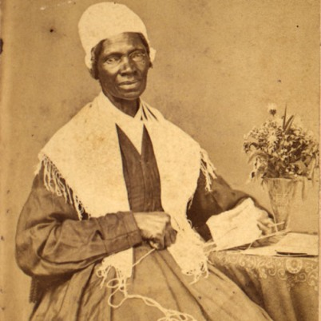
Sojourner Truth

Born in New York circa 1797, Sojourner Truth was the self-given name, from 1843 onward, of Isabella Baumfree, an African-American abolitionist and women's rights activist. Truth was born into slavery in Swartekill, New York, but escaped with her infant daughter to freedom in 1826. Her best-known speech on racial inequalities, "Ain't I a Woman?", was delivered extemporaneously in 1851 at the Ohio Women's Rights Convention.

Born Into Slavery

Born Isabella Baumfree circa 1797, Sojourner Truth was one of as many as 12 children born to James and Elizabeth Baumfree in the town of Swartekill, in Ulster County, New York. Truth's date of birth was not recorded, as was typical of children born into slavery. Historians estimate that she was likely born around 1787. Her father, James Baumfree, was a slave captured in modern-day Ghana; Elizabeth Baumfree, also known as Mau-Mau Bet, was the daughter of slaves from Guinea. The Baumfree family was owned by Colonel Hardenbergh, and lived at the colonel's estate in Esopus, New York, 95 miles north of New York City. The area had once been under Dutch control, and both the Baumfrees and the Hardenbaughs spoke Dutch in their daily lives.

After the colonel's death, ownership of the Baumfrees passed to his son, Charles. The Baumfrees were separated after the death of Charles Hardenbergh in 1806. The 9-year-old Truth, known as "Belle" at the time, was sold at an auction with a flock of sheep for $100. Her new owner was a man named John Neely, whom Truth remembered as harsh and violent. She would be sold twice more over the following two years, finally coming to reside on the property of John Dumont at West Park, New York. It was during these years that Truth learned to speak English for the first time.

Becoming a Wife and Mother

Around 1815, Truth fell in love with a slave named Robert from a neighboring farm. The two had a daughter, Diana. Robert's owner forbade the relationship, since Diana and any subsequent children produced by the union would be the property of John Dumont rather than himself. Robert and Sojourner Truth never saw each other again. In 1817, Dumont compelled Truth to marry an older slave named Thomas. Their marriage produced a son, Peter, and two daughters, Elizabeth and Sophia.

Early Years of Freedom

The state of New York, which had begun to negotiate the abolition of slavery in 1799, emancipated all slaves on July 4, 1827. The shift did not come soon enough for Truth. After John Dumont reneged on a promise to emancipate Truth in late 1826, she escaped to freedom with her infant daughter, Sophia. Her other daughter and son stayed behind. Shortly after her escape, Truth learned that her son Peter, then 5 years old, had been illegally sold to a man in Alabama. She took the issue to court and eventually secured Peter's return from the South. The case was one of the first in which a black woman successfully challenged a white man in a United States court.

Sojourner Truth's early years of freedom were marked by several strange hardships.

Having converted to Christianity, Truth she moved with her son Peter to New York City in 1829, where she worked as a housekeeper for Christian evangelist Elijah Pierson. She then moved on to the home of Robert Matthews, also known as Matthias Kingdom or Prophet Matthias, for whom she also worked as a domestic. Matthews had a growing reputation as a con man and a cult leader. Shortly after Truth changed households,

Elijah Pierson died. Robert Matthews and Truth were immediately accused of poisoning Pierson in order to benefit from his personal fortune. Both were acquitted, and Robert Matthews, who had become a favorite subject of the penny press, moved west.

After her successful rescue of her son, Peter, from slavery in Alabama, the boy stayed with his mother until 1839. At that time, Peter took a job on a whaling ship called the Zone of Nantucket. Truth received three letters from her son between 1840 and 1841. When the ship returned to port in 1842, however, Peter was not on board. Truth never heard from him again.

Fighting for Abolition and Women's Rights

On June 1, 1843, Isabella Baumfree changed her name to Sojourner Truth, devoting her life to Methodism and the abolition of slavery. In 1844, she joined the Northampton Association of Education and Industry in Northampton, Massachusetts. Founded by abolitionists, the organization supported a broad reform agenda including women's rights and pacifism. Members lived together on 500 acres as a self-sufficient community. Truth met a number of leading abolitionists at Northampton, including William Lloyd Garrison, Frederick Douglass and David Ruggles.

Although the Northampton community disbanded in 1846, Sojourner Truth's career as an activist and reformer was just beginning. William Lloyd Garrison published her memoirs in 1850 under the title The Narrative of Sojourner Truth: A Northern Slave. Truth dictated her recollections to a friend, since she could not read or write. That same year, Truth spoke at the first National Women's Rights Convention in Worcester, Massachusetts. She soon began touring regularly with abolitionist George Thompson, speaking to large crowds on the subjects of slavery and human rights. She was one of several escaped slaves, along with Frederick Douglass and Harriet Tubman, to rise to prominence as an abolitionist leader and a testament to the humanity of enslaved people.

In May of 1851, Truth delivered a speech at the Ohio Women's Rights Convention in Akron. The extemporaneous speech, recorded by several observers, would come to be known as "Ain't I a Woman?" The first version of the speech, published a month later by Ohio Anti-Slavery Bugle editor Marius Robinson, did not include the question "Ain't I a woman?" even once. Robinson had attended the convention and recorded Truth's words himself. The famous phrase would appear in print 12 years later, as the refrain of a Southern-tinged version of the speech. It is unlikely that Sojourner Truth, a native of New York whose first language was Dutch, would have spoken in this Southern idiom.

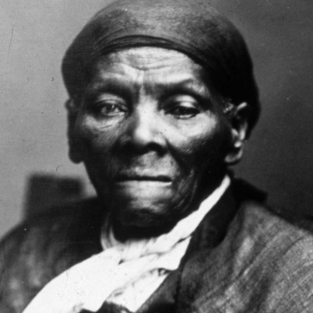
Harriet Tubman

Harriet Tubman was an American bondwoman who escaped from slavery in the South to become a leading abolitionist before the American Civil War. She was born in Maryland in 1820, and successfully escaped in 1849. Yet she returned many times to rescue both family members and non-relatives from the plantation system. She led hundreds to freedom in the North as the most famous "conductor" on the Underground Railroad, an elaborate secret network of safe houses organized for that purpose.

Early Life

Harriet Tubman was born to enslaved parents in Dorchester County, Maryland, and originally named Araminta Harriet Ross. Her mother, Harriet “Rit” Green, was owned by Mary Pattison Brodess. Her father, Ben Ross, was owned by Anthony Thompson, who eventually married Mary Brodess. Araminta, or “Minty,” was one of nine children born to Rit and Ben between 1808 and 1832. While the year of Araminta’s birth is unknown, it probably occurred between 1820 and 1825.

Minty’s early life was full of hardship. Mary Brodess’ son Edward sold three of her sisters to distant plantations, severing the family. When a trader from Georgia approached Brodess about buying Rit’s youngest son, Moses, Rit successfully resisted the further fracturing of her family, setting a powerful example for her young daughter.

Physical violence was a part of daily life for Tubman and her family. The violence she suffered early in life caused permanent physical injuries. Harriet later recounted a particular day when she was lashed five times before breakfast. She carried the scars for the rest of her life. The most severe injury occurred when Tubman was an adolescent. Sent to a dry-goods store for supplies, she encountered a slave who had left the fields without permission. The man’s overseer demanded that Tubman help restrain the runaway. When Harriet refused, the overseer threw a two-pound weight that struck her in the head. Tubman endured seizures, severe headaches and narcoleptic episodes for the rest of her life. She also experienced intense dream states, which she classified as religious experiences.

The line between freedom and slavery was hazy for Tubman and her family. Harriet Tubman’s father, Ben, was freed from slavery at the age of 45, as stipulated in the will of a previous owner. Nonetheless, Ben had few options but to continue working as a timber estimator and foreman for his former owners. Although similar manumission stipulations applied to Rit and her children, the individuals who owned the family chose not to free them. Despite his free status, Ben had little power to challenge their decision.

By the time Harriet reached adulthood, around half of the African-American people on the eastern shore of Maryland were free. It was not unusual for a family to include both free and enslaved people, as did Tubman’s immediate family. In 1844, Harriet married a free black man named John Tubman. Little is known about John Tubman or his marriage to Harriet. Any children they might have had would have been considered enslaved, since the mother’s status dictated that of any offspring.

Araminta changed her name to Harriet around the time of her marriage, possibly to honor her mother.
Escape from Slavery and Abolitionism

Harriet Tubman escaped from slavery in 1849, fleeing to Philadelphia. Tubman decided to escape following a bout of illness and the death of her owner in 1849. Tubman feared that her family would be further severed, and feared for own her fate as a sickly slave of low economic value. She initially left Maryland with two of her brothers, Ben and Henry, on September 17, 1849. A notice published in the Cambridge Democrat offered a $300 reward for the return of Araminta (Minty), Harry and Ben. Once they had left, Tubman’s brothers had second thoughts and returned to the plantation. Harriet had no plans to remain in bondage. Seeing her brothers safely home, she soon set off alone for Pennsylvania.

Tubman made use of the network known as the Underground Railroad to travel nearly 90 miles to Philadelphia. She crossed into the free state of Pennsylvania with a feeling of relief and awe, and recalled later: “When I found I had crossed that line, I looked at my hands to see if I was the same person. There was such a glory over everything; the sun came like gold through the trees, and over the fields, and I felt like I was in Heaven.”

Rather than remaining in the safety of the North, Tubman made it her mission to rescue her family and others living in slavery. In December 1850, Tubman received a warning that her niece Kessiah was going to be sold, along with her two young children. Kessiah’s husband, a free black man named John Bowley, made the winning bid for his wife at an auction in Baltimore. Harriet then helped the entire family make the journey to Philadelphia. This was the first of many trips by Tubman, who earned the nickname “Moses” for her leadership. Over time, she was able to guide her parents, several siblings and about 60 others to freedom. One family member who declined to make the journey was Harriet’s husband, John, who preferred to stay in Maryland with his new wife.

The dynamics of escaping slavery changed in 1850, with the passage of the Fugitive Slave Law. This law stated that escaped slaves could be captured in the North and returned to slavery, leading to the abduction of former slaves and free blacks living in Free States. Law enforcement officials in the North were compelled to aid in the capture of slaves, regardless of their personal principles. In response to the law, Tubman re-routed the Underground Railroad to Canada, which prohibited slavery categorically.

In December 1851, Tubman guided a group of 11 fugitives northward. There is evidence to suggest that the party stopped at the home of abolitionist and former slave Frederick Douglass.

In April 1858, Tubman was introduced to the abolitionist John Brown, who advocated the use of violence to disrupt and destroy the institution of slavery. Tubman shared Brown’s goals and at least tolerated his methods. Tubman claimed to have had a prophetic vision of Brown before they met. When Brown began recruiting supporters for an attack on slaveholders at Harper’s Ferry, he turned to “General Tubman” for help.

