Women in the Revolution
1. What are the roles of men and women in today’s society?
Men | Women

2. What are the traditional roles of men and women?

Men | Women
3. What is a patriarchal society?

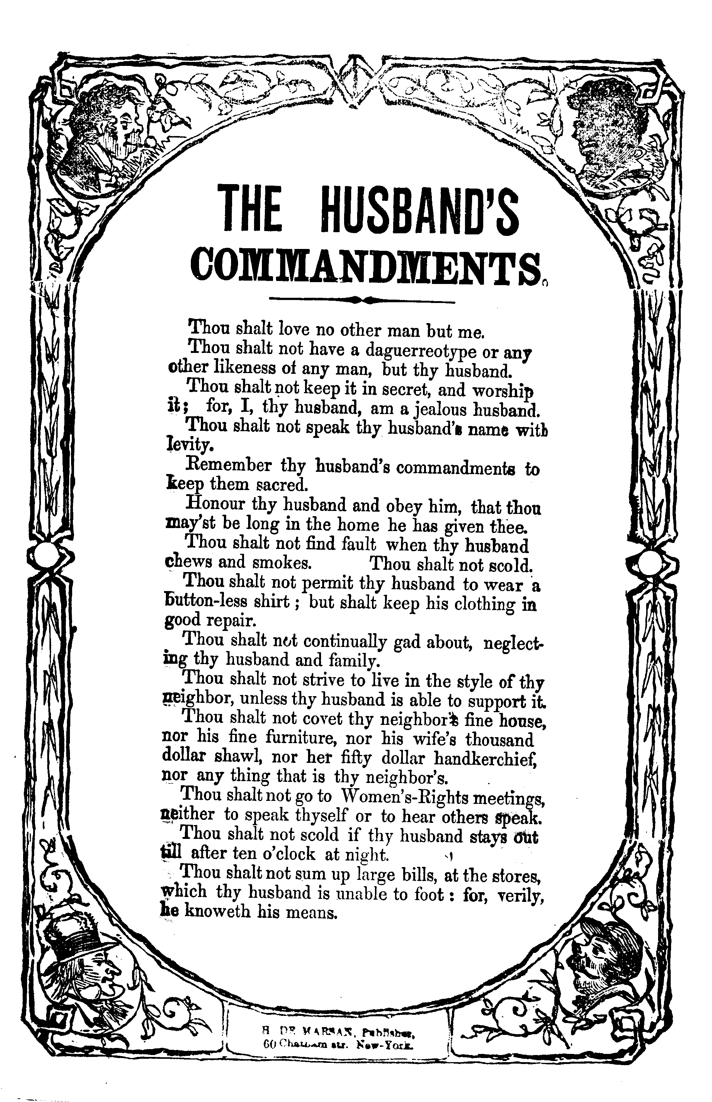

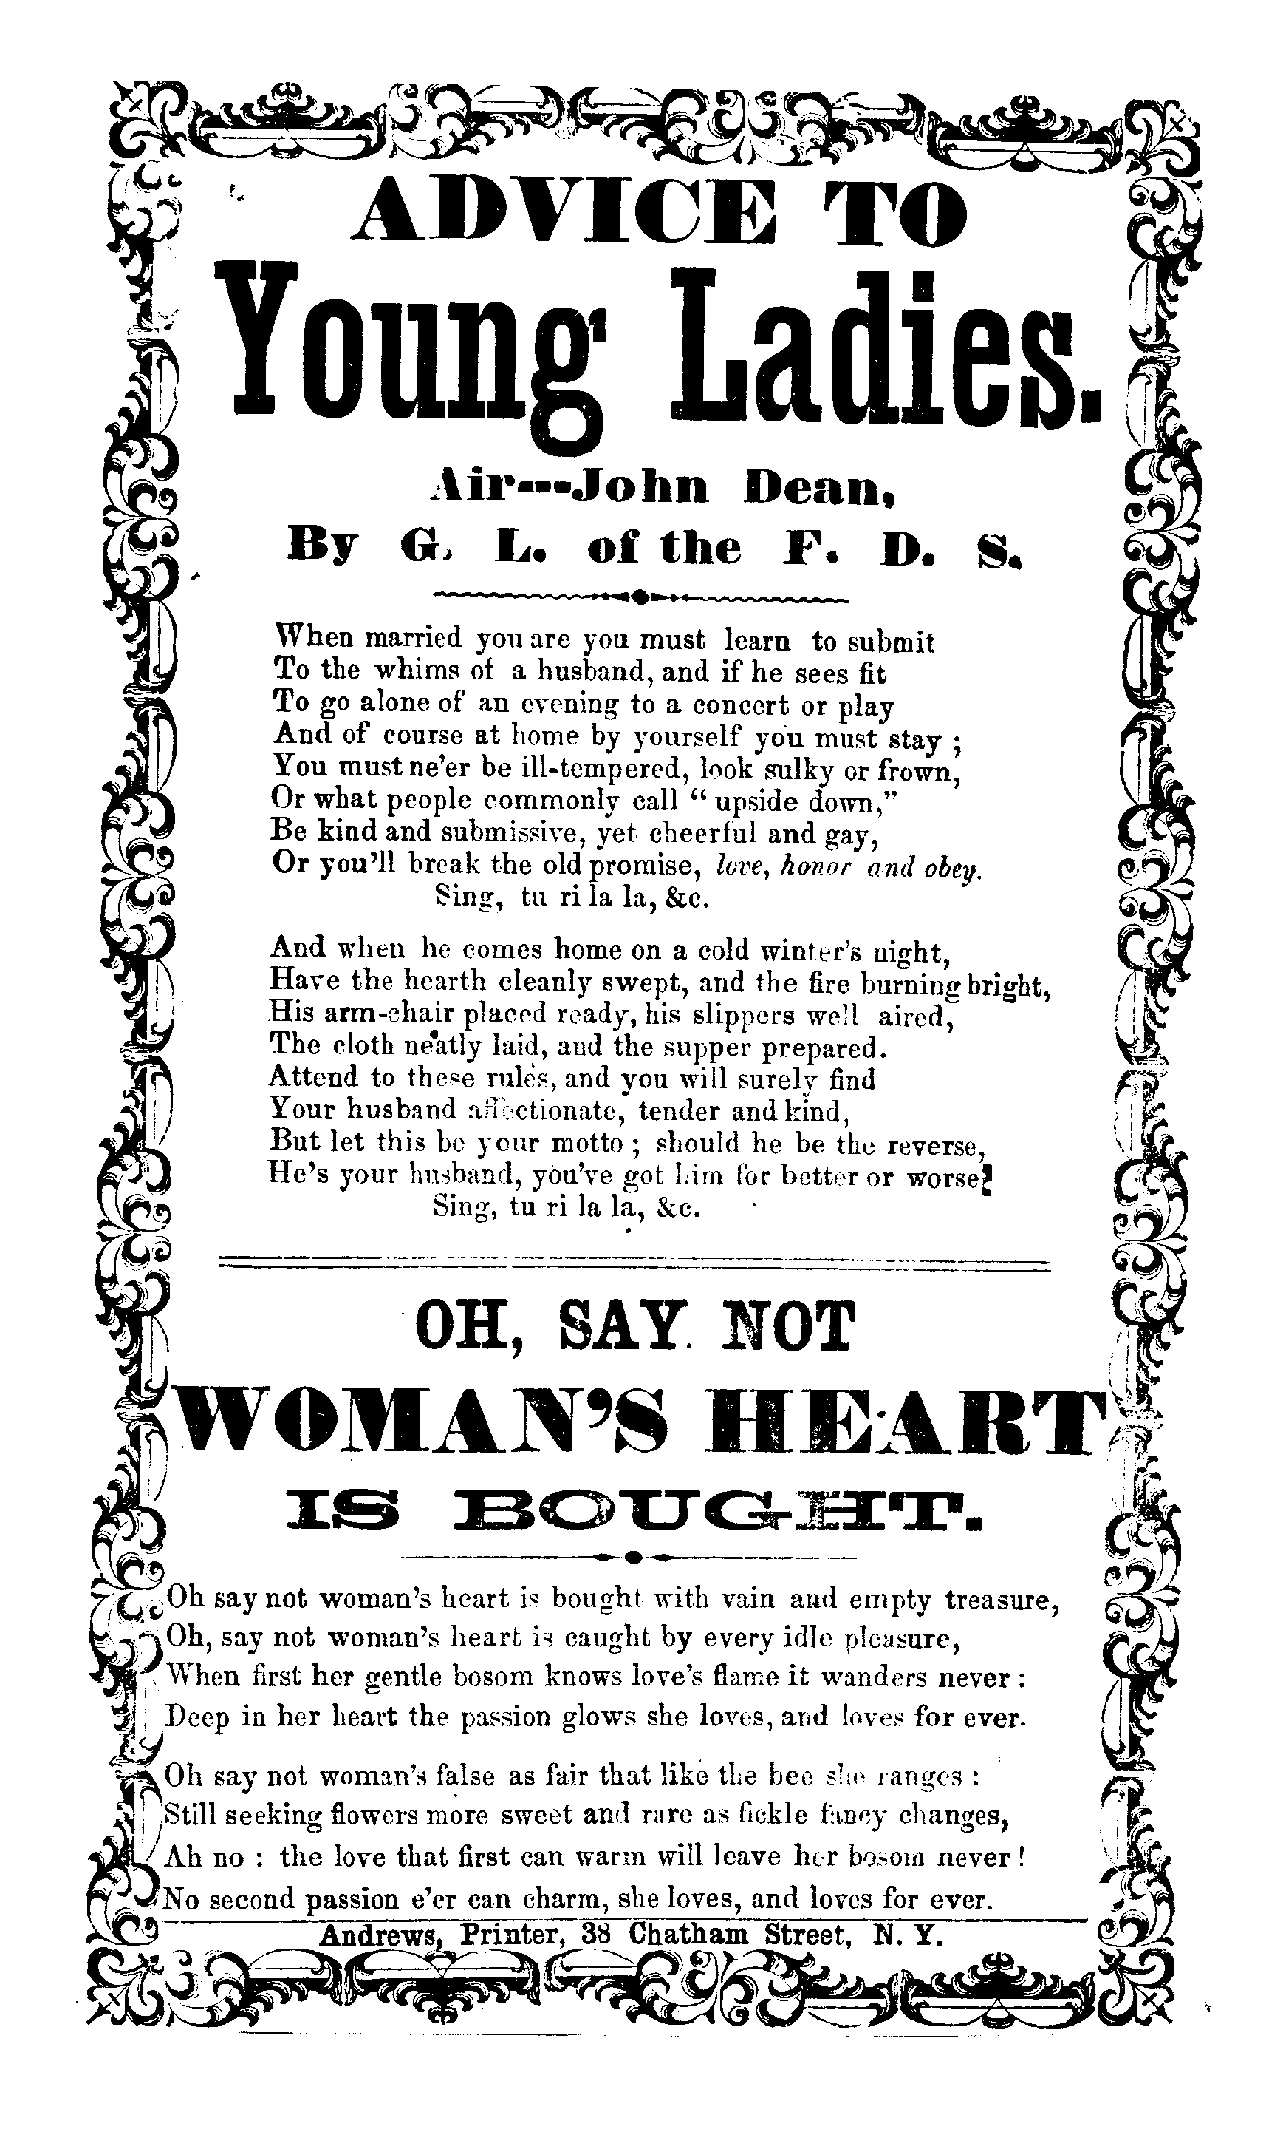
____________________________________________________________________________________________________________________________________________________________________________________________________________________________________________________________________________________________________________________________________________________________________________________________________________________________________________________________________________________________

Reading 1:
In the new Code of Laws which I suppose it will be necessary for you to make I desire you would Remember the Ladies, and be more generous and favourable to them than your ancestors. Do not put such unlimited power into the hands of the Husbands. Remember all Men would be tyrants if they could. If particular care and attention is not paid to the Ladies we are determined to foment a Rebellion, and will not hold ourselves bound by any Laws in which we have no voice, or Representation.
Reading 2:
That your Sex are Naturally Tyrannical is a Truth so thoroughly established as to admit of no dispute Why then, not put it out of the power of the vicious and the Lawless to use us with cruelty and indignity with impunity
Abigail Adams to John Adams, March 31, 1776
Reading 3:
As to your extraordinary Code of Laws, I cannot but laugh. We have been told that our Struggle has loosened the bands of Government everywhere. That Children and Apprentices were disobedient--that schools and Colleges were grown turbulent--that Indians slighted their Guardians and Negroes grew insolent to their Masters. But your Letter was the first Intimation that another Tribe more numerous and powerful than all the rest were grown discontented Depend upon it, We know better than to repeal our Masculine systems We have only the Name of Masters. and rather than give up this, which would completely subject Us to the Despotism of the Petticoat, I hope General Washington, and all our brave Heroes would fight.
John Adams to Abigail Adams, April 14, 1776

What does Abigail Adams want?

How does John Adams feel about Women’s rights?

