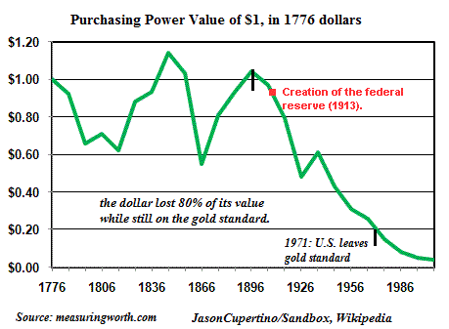

http://www.zerohedge.com/sites/default/files/images/user5/imageroot/2012/07-2/Dollar-value1776-2008a.gif

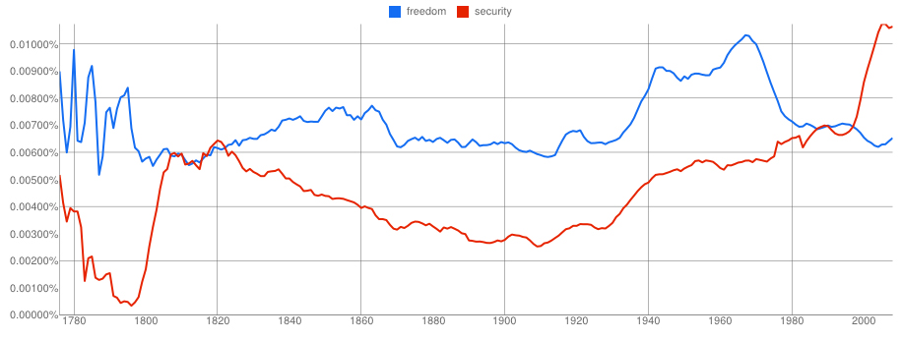
http://irregulartimes.com/wp-content/uploads/2012/06/zoolongamerican.jpg

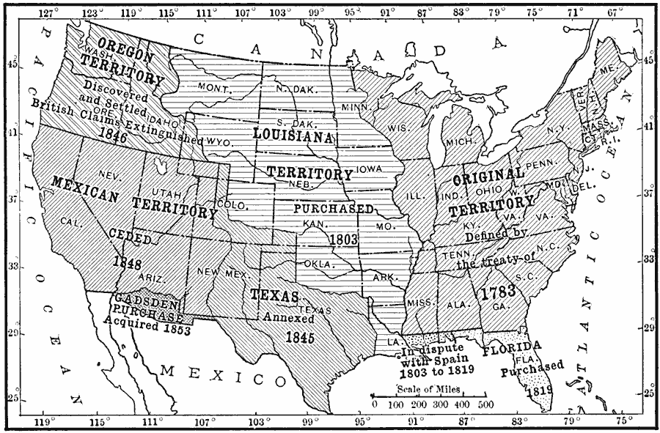

http://etc.usf.edu/maps/pages/2000/2091/2091.htm

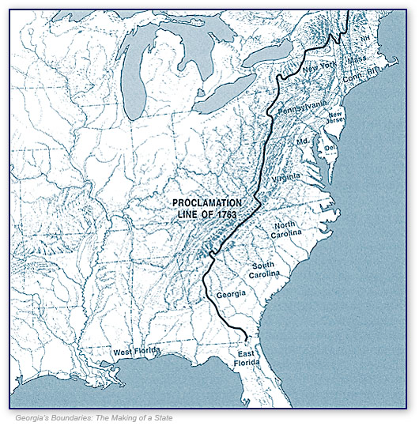
http://georgiainfo.galileo.usg.edu/tdgh-oct/Proclamation%20Line%20of%201763.jpg
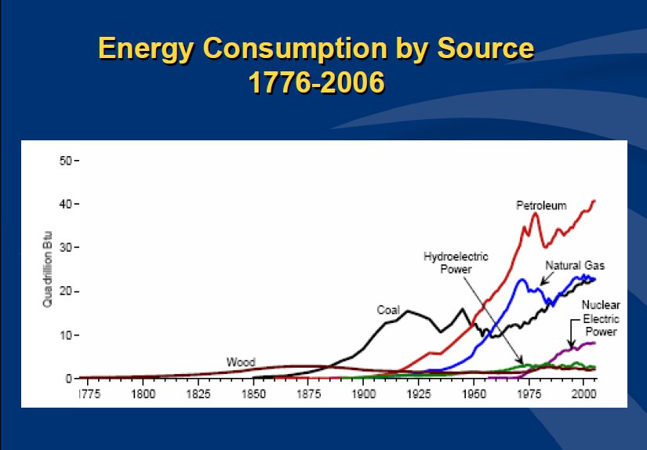

http://www.intellectualtakeout.org/sites/www.intellectualtakeout.org/files/chart-graph/Chart1.jpg

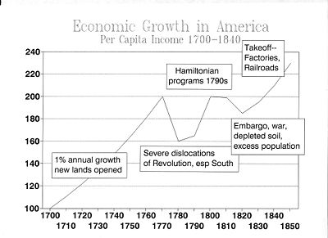
http://upload.wikimedia.org/wikipedia/commons/thumb/4/49/GROWTH1850.JPG/400px-GROWTH1850.JPG

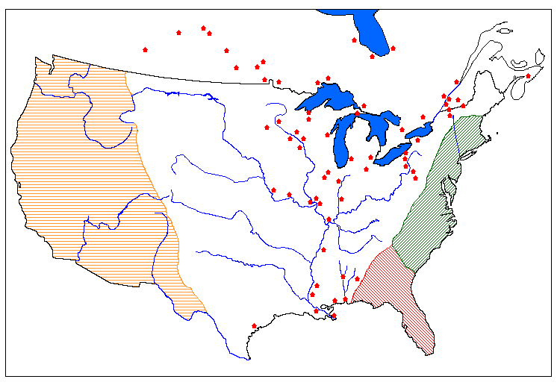
British Forts 1783
http://www.llsh.univ-savoie.fr/lea/perdrieau/defs.htm

Pre-Revolutionary ministers, particularly in Puritan Massachusetts, preached the moral superiority of men. Enlightened thinkers rejected this and knew that a republic could only succeed if its citizens were virtuous and educated. Who were the primary caretakers of American children? American women. If the republic were to succeed, women must be schooled in virtue so they could teach their children. The first American female academies were founded in the 1790s. This idea of an educated woman became known as "REPUBLICAN MOTHERHOOD."
http://www.ushistory.org/us/12d.asp

SLAVERY was a central institution in American society during the late-18th century, and was accepted as normal and applauded as a positive thing by many white Americans. However, this broad acceptance of slavery (which was never agreed to by black Americans) began to be challenged in the Revolutionary Era. The challenge came from several sources, partly from Revolutionary ideals, partly from a new evangelical religious commitment that stressed the equality of all Christians, and partly from a decline in the profitability of TOBACCO in the most significant slave region of Virginia and adjoining states.
The decline of slavery in the period was most noticeable in the states north of Delaware, all of which passed laws outlawing slavery quite soon after the end of the war. However, these gradual emancipation laws were very slow to take effect — many of them only freed the children of current slaves, and even then, only when the children turned 25 years old. Although laws prohibited slavery in the North, the "PECULIAR INSTITUTION" persisted well into the 19th century.
http://www.ushistory.org/us/13d.asp

