Mexican American War 1846-1847
Label the following items on your map. Color-code the map to distinguish the various areas of territories and countries.

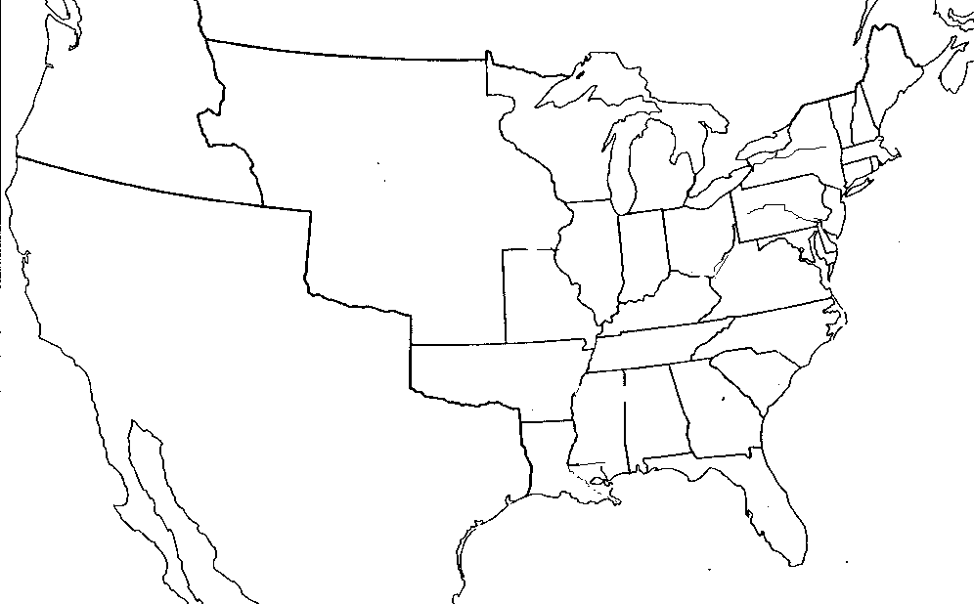

Bodies of Water
- Gulf of California
- Gulf of Mexico
- Pacific Ocean
- Rio Grande
- Mississippi River
- Gila River

Territories and States
- Oregon Territory
- Mexico
- Each State in US
- Louisiana Territory
- United States
- Territory under dispute (won/lost)

