Document A: Missouri Compromise
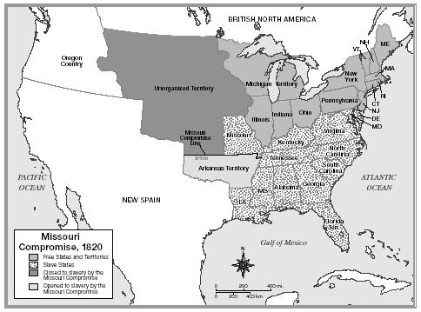

Document B: Monroe Doctrine Transcript
The Monroe Doctrine was expressed during President Monroe's seventh annual message to Congress, December 2, 1823

We owe it, therefore, to candor and to the amicable relations existing between the United States and those powers to declare that we should consider any attempt on their part to extend their system to any portion of this hemisphere as dangerous to our peace and safety. With the existing colonies or dependencies of any European power we have not interfered and shall not interfere. But with the Governments who have declared their independence and maintain it, and whose independence we have, on great consideration and on just principles, acknowledged, we could not view any interposition for the purpose of oppressing them, or controlling in any other manner their destiny, by any European power in any other light than as the manifestation of an unfriendly disposition toward the United States.

Document C: States by Order of Entry into Union
http://www.infoplease.com/ipa/A0763770.html
State | Entered  Union | Year  settled
1. Delaware | Dec. 7, 1787 | 1638
2. Pennsylvania | Dec. 12, 1787 | 1682
3. New Jersey | Dec. 18, 1787 | 1660
4. Georgia | Jan. 2, 1788 | 1733
5. Connecticut | Jan. 9, 1788 | 1634
6. Massachusetts | Feb. 6, 1788 | 1620
7. Maryland | Apr. 28, 1788 | 1634
8. South Carolina | May 23, 1788 | 1670
9. New Hampshire | June 21, 1788 | 1623
10. Virginia | June 25, 1788 | 1607
11. New York | July 26, 1788 | 1614
12. North Carolina | Nov. 21, 1789 | 1660
13. Rhode Island | May 29, 1790 | 1636
14. Vermont | Mar. 4, 1791 | 1724
15. Kentucky | June 1, 1792 | 1774
16. Tennessee | June 1, 1796 | 1769
17. Ohio | Mar. 1, 1803 | 1788
18. Louisiana | Apr. 30, 1812 | 1699
19. Indiana | Dec. 11, 1816 | 1733
20. Mississippi | Dec. 10, 1817 | 1699
21. Illinois | Dec. 3, 1818 | 1720
22. Alabama | Dec. 14, 1819 | 1702
23. Maine | Mar. 15, 1820 | 1624
24. Missouri | Aug. 10, 1821 | 1735
25. Arkansas | June 15, 1836 | 1686
26. Michigan | Jan. 26, 1837 | 1668
27. Florida | Mar. 3, 1845 | 1565
Read more: States by Order of Entry into Union | Infoplease.com http://www.infoplease.com/ipa/A0763770.html#ixzz2tulqbxAq

