Group 1: The African-American Perspective

Woman Suffrage
By W.E.B. Du Bois, The Crisis, pp. 29–30, 1915
This month 200,000 Negro voters will be called upon to vote on the question of giving the right of suffrage to women. THE CRISIS sincerely trusts that everyone of them will vote Yes. But THE CRISIS would not have them go to the polls without having considered every side of the question. Intelligence in voting is the only real support of democracy. For this reason we publish with pleasure Dean Kelly Miller's article against woman suffrage. We trust that our readers will give it careful attention and that they will compare it with that marvelous symposium which we had the pleasure to publish in our August number. Meantime, Dean Miller will pardon us for a word in answer to his argument.

Briefly put, Mr. Miller believes that the bearing and rearing of the young is a function which makes it practically impossible for women to take any large part in general, industrial and public affairs; that women are weaker than men; that women are adequately protected under man's suffrage; that no adequate results have appeared from woman suffrage and that office-holding by women is "risky."

All these arguments sound today ancient. If we turn to easily available statistics we find that instead of the women of this country or of any other country being confined chiefly to childbearing they are as a matter of fact engaged and engaged successfully in practically every pursuit in which men are engaged. The actual work of the world today depends more largely upon women than upon men. Consequently this man-ruled world faces an astonishing dilemma: either Woman the Worker is doing the world's work successfully or not. If she is not doing it well why do we not take from her the necessity of working? If she is doing it well why not treat her as a worker with a voice in the direction of work?
The statement that woman is weaker than man is sheer rot: It is the same sort of thing that we hear about "darker races" and "lower classes." Difference, either physical or spiritual, does not argue weakness or inferiority. That the average woman is spiritually different from the average man is undoubtedly just as true as the fact that the average white man differs from the average Negro; but this is no reason for disfranchising the Negro or lynching him. It is inconceivable that any person looking upon the accomplishments of women today in every field of endeavor, realizing their humiliating handicap and the astonishing prejudices which they face and yet seeing despite this that in government, in the professions, in sciences, art and literature and the industries they are leading and dominating forces and growing in power as their emancipation grows,--it is inconceivable that any fair-minded person could for a moment talk about a "weaker" sex. The sex of Judith, Candace, Queen Elizabeth, Sojourner Truth and Jane Addams was the merest incident of human function and not a mark of weakness and inferiority.

To say that men protect women with their votes is to overlook the flat testimony of the facts. In the first place there are millions of women who have no natural men protectors: the unmarried, the widowed, the deserted and those who have married failures. To put this whole army incontinently out of court and leave them unprotected and without voice in political life is more than unjust, it is a crime.
There was a day in the world when it was considered that by marriage a woman lost all her individuality as a human soul and simply became a machine for making men. We have outgrown that idea. A woman is just as much a thinking, feeling, acting person after marriage as before. She has opinions and she has a right to have them and she has a right to express them. It is conceivable, of course, for a country to decide that its unit of representation should be the family and that one person in that family should express its will. But by what possible process of rational thought can it be decided that the person to express that will should always be the male, whether he be genius or drunkard, imbecile or captain of industry? The meaning of the twentieth century is the freeing of the individual soul; the soul longest in slavery and still in the most disgusting and indefensible slavery is the soul of womanhood. God give her increased freedom this November!

Mr. Miller is right in saying that the results from woman suffrage have as yet been small but the answer is obvious: the experiment has been small. As for the risks of allowing women to hold office: Are they nearly as great as the risks of allowing working men to hold office loomed once in the eyes of the Intelligent Fearful?

Copyright (c) 1915 The Crisis. All Rights Reserved.
[Articles on BRC-NEWS may be forwarded and posted on other mailing lists/discussion forums, as long as proper attribution is given to the author and originating publication, and the wording is not altered in any way. In particular, if there is a reference to a web site where an article was originally located, please do *not* remove that.
Unless stated otherwise, do *not* publish or post the entire text of any copyrighted articles on web sites (web-based discussion forums exempted) or in print, without getting *explicit* permission from the article author or copyright holder. Check the fair use provisions of the copyright law in your country for details on what you can and can't do.
As a courtesy, we'd appreciate it if you let folks know how to subscribe to BRC-NEWS, by leaving in the first two lines of the signature below.] BRC-NEWS: Black Radical Congress - General News/Alerts/Announcements
Subscribe: Email "subscribe brc-news" to <majordomo@tao.ca>

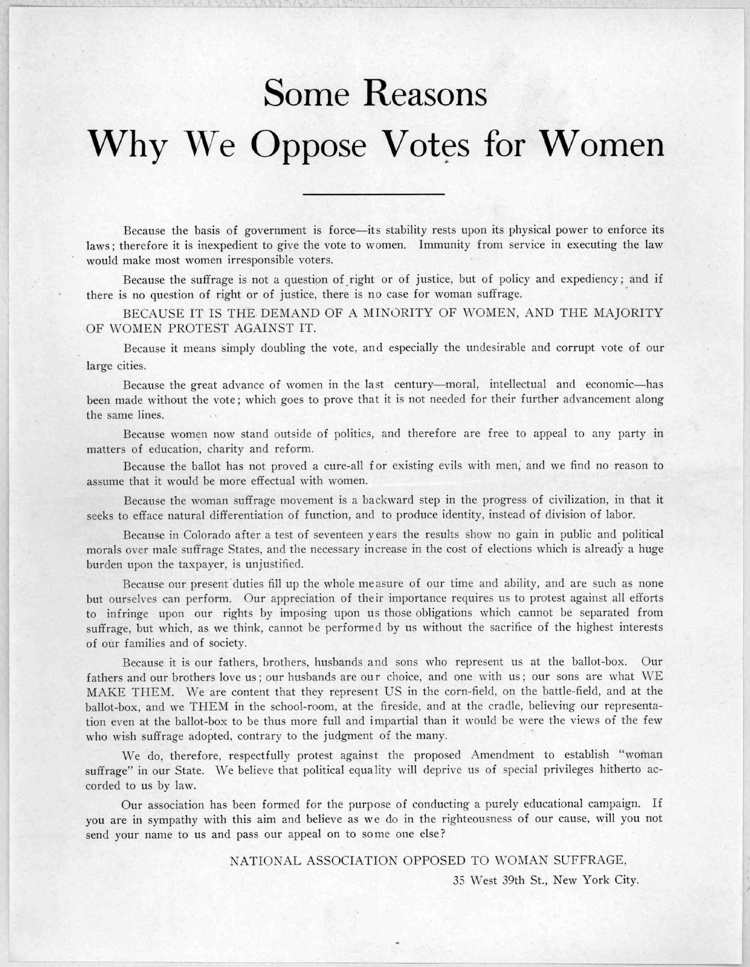

Group 6: Do Women Even Want the Vote?

Do want want the vote? ... Issued by the National state association opposed to woman suffrage, 29 West 39th Street, New York [1894].

DO WOMEN WANT THE VOTE?
Suffrage is not a natural right. It is a question to be determined by the community solely by a consideration of its effect upon the public welfare. The majority of the women do not want to assume the burden of government. A very small minority of women demand the ballot. It is unjust to force new duties upon a large body of women who are indifferent or opposed to woman suffrage.
Voting is only a small part of government. If the duty of voting is laid upon women, the duty will also be laid upon them of taking an active part in the preliminaries necessary to voting, and in the consequences which result from voting. They must take part in political discussions and share in political campaigns, and see that the laws which they help to enact are enforced upon those that refuse to obey the laws.
Would it Promote the General Welfare?
Woman suffrage would double the number of voters and double the expense of elections to the tax payer, without any corresponding gain. The need of America is not an increased quantity, but an improved quality of the vote, and there is no adequate reason to believe that Woman Suffrage, by doubling the vote, will improve its quality.
Would it not impose Great Hardship on Many Women?
Equality in character does not imply similarity in function; the duties and life of men and women are different in the State, as in the home. Women have many physical limitations which do not exist for men, and already, as a rule their strength is over-taxed. The energies of women are engrossed by their present duties and interests, from which men cannot relieve them, and it is better for the community that they devote their energies to the better performance of their present work, than to divert them to new fields of activity. The ballot is not essential for the performance of woman's present duties.
Are not the Interests of Women Safe in the Hands of Men?
Quite as safe as in those of other women!
The woman suffragists always imply that men legislate only for their own interests. But in America men cannot be accused of indifference to the wishes and happiness of women. They would make any reasonable amendments in the laws affecting the welfare of women, if urged with half the force now brought to bear in favor of suffrage. Moreover, in general the interests of men and women are very much the same. Both desire good schools, good roads, good drainage, and good government. The prosperity of the town and of the State benefits both alike. Only in the common division of labor, certain duties are apportioned to each, according to their special conditions of strength and organization. These differences are not of human origin, and therefore cannot be changed by any so-called "reform."
Political equality will deprive woman of special privileges hitherto accorded to her by law.
Will Woman Suffrage Help the Cause of Temperance?
No woman suffrage State is a prohibition State; no woman suffrage State is a high license State. Eight States where woman do not vote are prohibition States.
Is the Ballot Essential to Woman's Public Usefulness?
Woman Suffrage would force woman into the political arena. This would impair her usefulness which she exercises to-day as a disinterested, non-partisan worker for the public good. She would duplicate man's work and lose her special value if she went into party politics.
What would happen to Legislation and Government?
Behind law there must always be force to make it effective. Women, by the limitations of their sex, are unfitted for the stern work of enforcing law. It would be ill for any State where legislation was shaped by women over the heads of a majority of men. Under such conditions you would soon have, not government, but chaos.
Issued by the NATIONAL STATE ASSOCIATION OPPOSED TO WOMAN SUFFRAGE 29 West 39th Street, New York.

Group 8: Woman's Work in the Home
Housework in Late 19th Century America
By Steven Mintz
Housework in nineteenth century America was harsh physical labor. Preparing even a simple meal was a time and energy consuming chore. Prior to the twentieth century, cooking was performed on a coal or wood burning stove. Unlike an electric or a gas range, which can be turned on with the flick of a single switch, cast iron and steel stoves were exceptionally difficult to use.

Ashes from an old fire had to be removed. Then, paper and kindling had to be set inside the stove, dampers and flues had to be carefully adjusted, and a fire lit. Since there were no thermostats to regulate the stove's temperature, a woman had to keep an eye on the contraption all day long. Any time the fire slackened, she had to adjust a flue or add more fuel.

Throughout the day, the stove had to be continually fed with new supplies of coal or wood - an average of fifty pounds a day. At least twice a day, the ash box had to be emptied, a task which required a woman to gather ashes and cinders in a grate and then dump them into a pan below. Altogether, a housewife spent four hours every day sifting ashes, adjusting dampers, lighting fires, carrying coal or wood, and rubbing the stove with thick black wax to keep it from rusting.

It was not enough for a housewife to know how to use a cast iron stove. She also had to know how to prepare unprocessed foods for consumption. Prior to the 1890s, there were few factory prepared foods. Shoppers bought poultry that was still alive and then had to kill and pluck the birds. Fish had to have scales removed. Green coffee had to be roasted and ground. Loaves of sugar had to pounded, flour sifted, nuts shelled, and raisins seeded.

Cleaning was an even more arduous task than cooking. The soot and smoke from coal and wood burning stoves blackened walls and dirtied drapes and carpets. Gas and kerosene lamps left smelly deposits of black soot on furniture and curtains. Each day, the lamp's glass chimneys had to be wiped and wicks trimmed or replaced. Floors had to scrubbed, rugs beaten, and windows washed. While a small minority of well-to-do families could afford to hire a cook at $5 a week, a waitress at $3.50 a week, a laundress at $3.50 a week, and a cleaning woman and a choreman for $1.50 a day, in the overwhelming majority of homes, all household tasks had to be performed by a housewife and her daughters.

Housework in nineteenth century America was a full-time job. Gro Svendsen, a Norwegian immigrant, was astonished by how hard the typical American housewife had to work. As she wrote her parents in l862:

We are told that the women of America have much leisure time but I haven't yet met any woman who thought so! Here the mistress of the house must do all the work that the cook, the maid and the housekeeper would do in an upper class family at home. Moreover, she must do her work as well as these three together do it in Norway.

Before the end of the nineteenth century, when indoor plumbing became common, chores that involved the use of water were particularly demanding. Well?to?do urban families had piped water or a private cistern, but the overwhelming majority of American families got their water from a hydrant, a pump, a well, or a stream located some distance from their house. The mere job of bringing water into the house was exhausting. According to calculations made in 1886, a typical North Carolina housewife had to carry water from a pump or a well or a spring eight to ten times each day. Washing, boiling and rinsing a single load of laundry used about 50 gallons of water. Over the course of a year she walked 148 miles toting water and carried over 36 tons of water.
Homes without running water also lacked the simplest way to dispose garbage: sinks with drains. This meant that women had to remove dirty dishwater, kitchen slops, and, worst of all, the contents of chamberpots from their house by hand.

Laundry was the household chore that nineteenth century housewives detested most. Rachel Haskell, a Nevada housewife, called it "the Herculean task which women all dread" and "the great domestic dread of the household."

On Sunday evenings, a housewife soaked clothing in tubs of warm water. When she woke up the next morning, she had to scrub the laundry on a rough washboard and rub it with soap made from lye, which severely irritated her hands. Next, she placed the laundry in big vats of boiling water and stirred the clothes about with a long pole to prevent the clothes from developing yellow spots. Then she lifted the clothes out of the vats with a washstick, rinsed the clothes twice, once in plain water and once with bluing, wrung the clothes out and hung them out to dry. At this point, clothes would be pressed with heavy flatirons and collars would be stiffened with starch.

The last years of the nineteenth century witnessed a revolution in the nature of housework. Beginning in the 1880s, with the invention of the carpet sweeper, a host of new "labor? saving" appliances were introduced. These included the electric iron (1903), the electric vacuum cleaner (1907), and the electric toaster (1912). At the same time, the first processed and canned foods appeared. In the 1870s, H.J. Heinz introduced canned pickles and sauerkraut; in the 1880s, Frano-American Co. introduced the first canned meals; and in the 1890s, Campbell's sold the first condensed soups. By the 1920s, the urban middle class enjoyed a myriad of new household conveniences, including hot and cold running water, gas stoves, automatic washing machines, refrigerators, and vacuum cleaners.

Yet despite the introduction of electricity, running water, and "labor-saving" household appliances, time spent on housework did not decline. Indeed, the typical full-time housewife today spends just as much time on housework as her grandmother or great-grandmother. In 1924, a typical housewife spent about 52 hours a week in housework. Half a century later, the average full-time housewife devoted 55 hours to housework. A housewife today spends less time cooking and cleaning up after meals, but she spends just as much time as her ancestors on housecleaning and even more time on shopping, household management, laundry, and childcare.

How can this be? The answer lies in a dramatic rise in the standards of cleanliness and childcare expected of a housewife. As early as the 1930s, this change was apparent to a writer in the Ladies Home Journal:
Because we housewives of today have the tools to reach it, we dig every day after the dust that grandmother left to spring cataclysm. If few of us have nine children for a weekly bath, we have two or three for a daily immersion. If our consciences don't prick us over vacant pie shelves or empty cookie jars, they do over meals in which a vitamin may be omitted or a calorie lacking.

